How to set up a Learner Profile

Step 1: Log in to Google Drive.
You will be tracking your progress with the NCSSFL-ACTFL Can-Do Statements using a document that you will modify and share with your teacher on Google Drive. To access your Google Drive account...

1. Go to http://drive.google.com/
2. Sign in using the same Google account that you set up your Language Portfolio folder in.

Step 2: Fill out your Learner Profile.
- Open the Language Portfolio - Learner Profile document by going to http://goo.gl/QKTwX8

- You'll need to make a copy of this document and save it in your Language Portfolio. To do this, click "File", then "Make a copy..." Don't change the name of the document unless your teacher tells you to. A copy of the document that you can edit will automatically open in a new window.
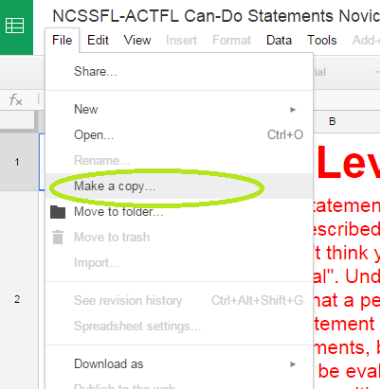
- Next, to move it into your language portfolio file, click "File", then "Move to folder..." and select your Language Portfolio folder in the window that pops up.
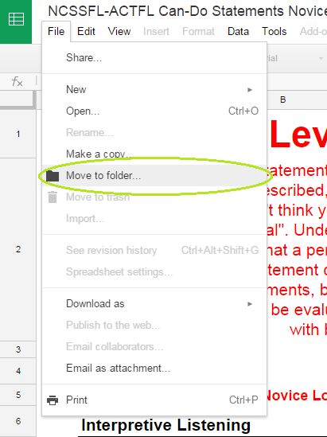

- Fill in the information in the document with HONEST, THOROUGH answers. Your teacher will be using this information to decide what topics to cover in class, make sure that you're in the correct level of language, and topics to cover in class. The better information you give, the better your experience in class will be!

