How to set up a LinguaFolio virtual portfolio and share it with your teacher

Step 1: Log in to Google Drive.
You will be tracking your progress with the NCSSFL-ACTFL Can-Do statements and using documents that you will modify and store in a folder that is shared with your teacher on Google Drive. To access your Google Drive account...

1. Go to http://drive.google.com/

2. Sign in using your Google account. Your teacher may want you to use your school-issued Google account. If not, they may allow you to use a personal account. If you don't have a Google account, you'll need to create one.

Step 2: Create a folder and share it.
- In Google Drive, click on the button labeled "Create". Click "Folder".
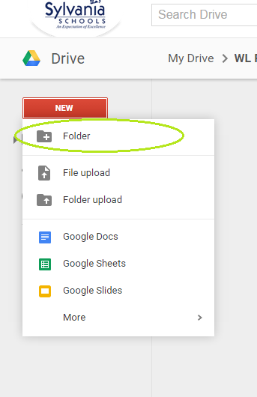

- Name your new folder Period Firstname Lastname Language Portfolio
Ex: 4 Alex Shall Language Portfolio would be the name of Alex Shall's folder in 4th period

- Right click on your folder and select "Share".
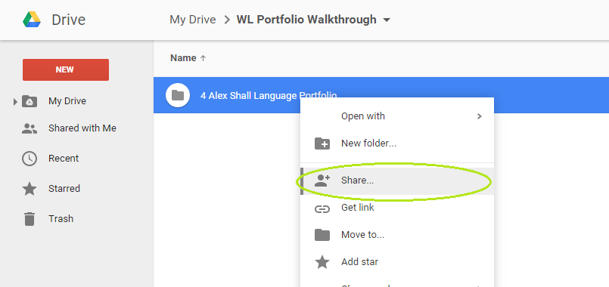

- A box will pop up. In the area labeled "People", enter your teacher's e-mail address.

- Click "Done". Your teacher will now have access to anything you place in this folder.

